Primitive Data Types:
---------------------------------
byte: Range: -128 to 127. Size - 1 byte. Default value is 0.
short: Range: -32,768 to 32,767. Size - 2 bytes. Default value is 0.
int: Range: -2^31 to 2^31 (-2,147,483,648 to 2,147,483,647). Size - 4 bytes [214 crore, 74 laks 83 thousand 6 hundred and 47]. Default value is 0.
long: Range: -2^63 to 2^63 (-9,223,372,036,854,775,808 to 9,223,372,036,854,775,807) . Size 8 bytes . Default value is 0L.
[Nine quintillion two hundred twenty-three quadrillion three hundred seventy-two trillion thirty-six billion eight hundred fifty-four million seven hundred seventy-five thousand eight hundred seven.]
float: It typically provides around 6-7 decimal digits of precision Example: 3.14f. Size - 4 bytes. Default value is 0.0f.
double: It typically provides around 15 decimal digits of precision. Example: 3.14. Size - 8 bytes. Default value is 0.0d.
char: 16-bit Unicode character. Size - 2 bytes. Default value is '\u0000' (represents the null character).
boolean: Represents true or false. Not precisely defined, but it's commonly considered to be implementation-dependent. Default value is false.

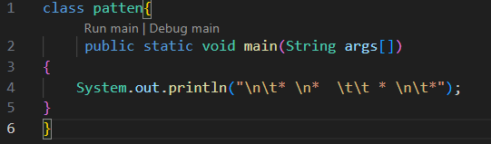
Output
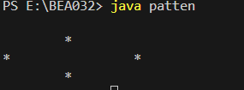
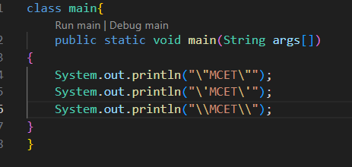
Output
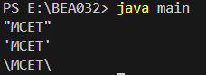
\- is the escape sequence.

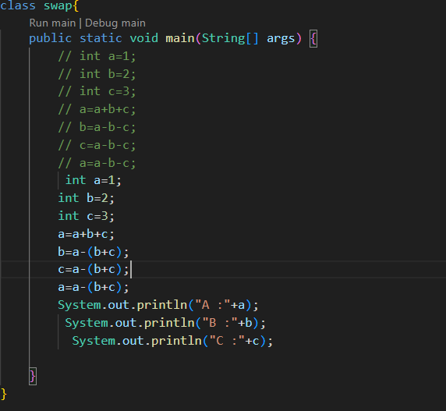
Output
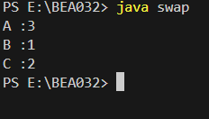

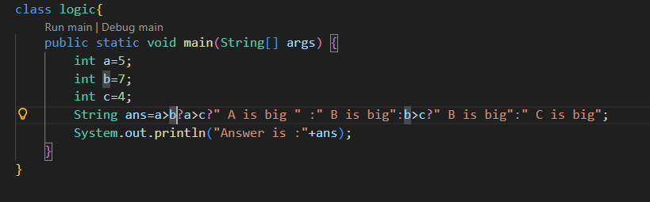
Output
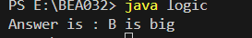
ASCII check
- NUMBER TO ASCII KEY
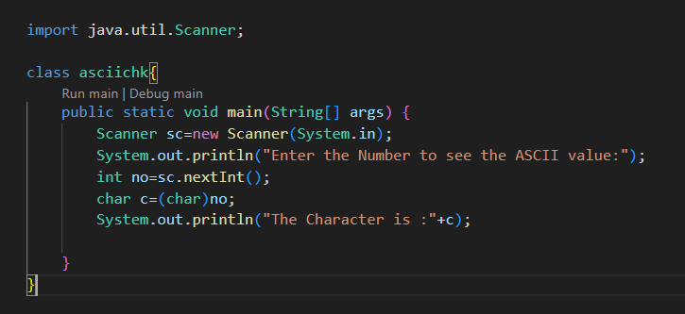
OUTPUT
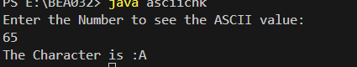
- ASCII TO NUMBER
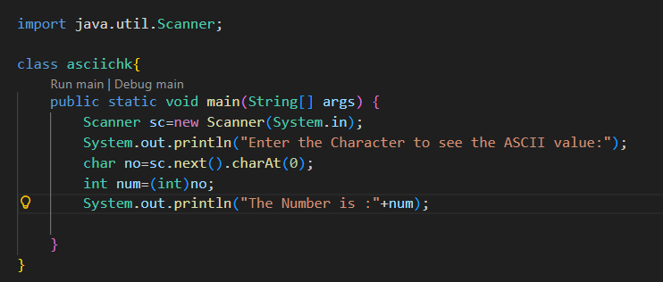
Output
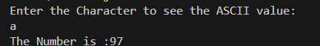

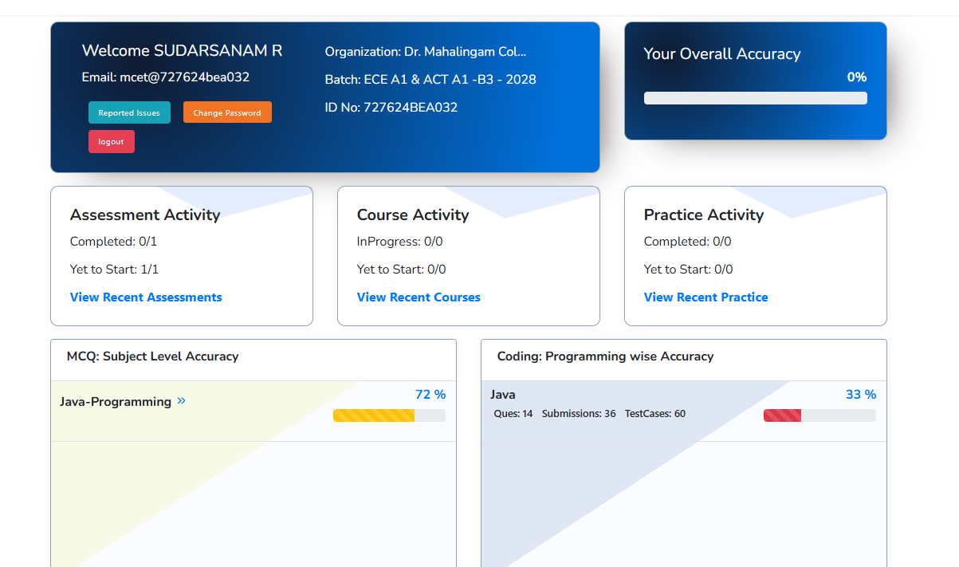

REVERSE WITHOUT ANY EXTRA VARIABLE

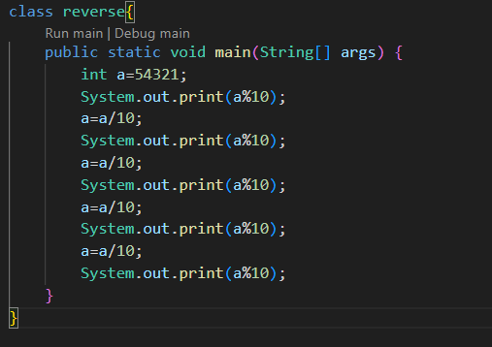
Output
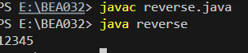

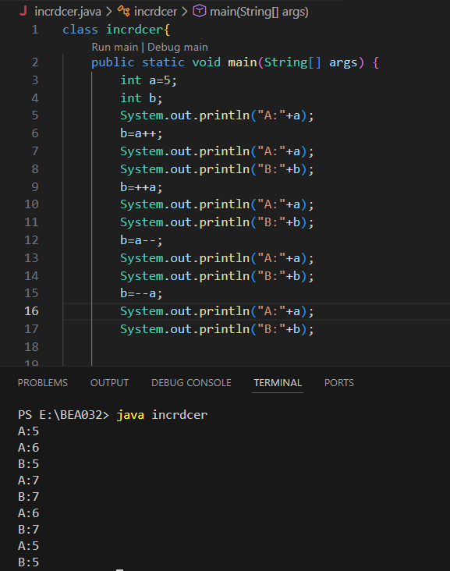

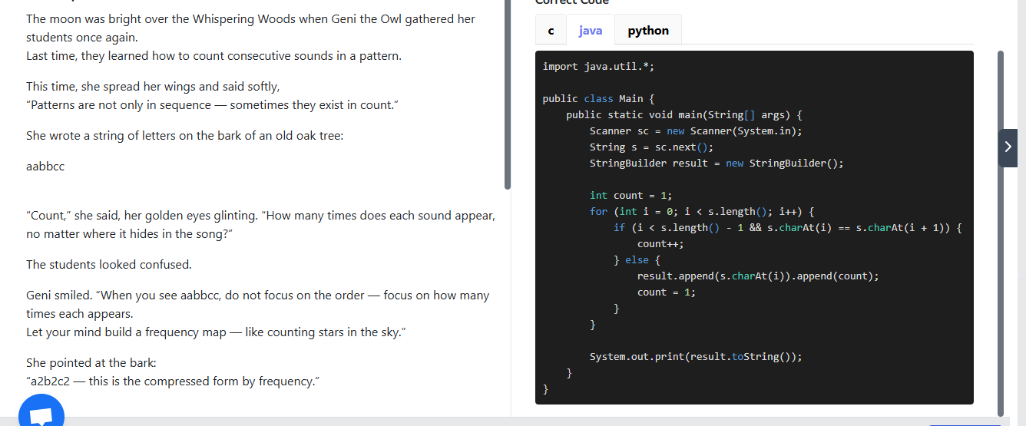
import java.util.Scanner;

public class FoxieSelfDividing {

// Check if number is self-dividing
public static boolean isSelfDividing(int n) {
int temp = n;
while (temp > 0) {
int digit = temp % 10;
if (digit == 0 || n % digit != 0) {
return false;
}
temp /= 10;
}
return true;
}

public static void main(String[] args) {
Scanner sc = new Scanner(System.in);
int left = sc.nextInt();
int right = sc.nextInt();
boolean first = true;
for (int i = left; i <= right; i++) {
if (isSelfDividing(i)) {
if (!first) {
System.out.print(" ");
}
System.out.print(i);
first = false;
}
}
System.out.println();
sc.close();
}
}

